附件1

# 01

# 02

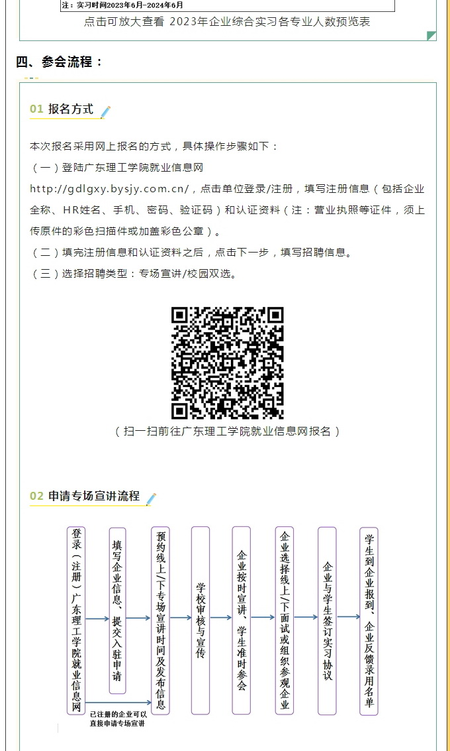

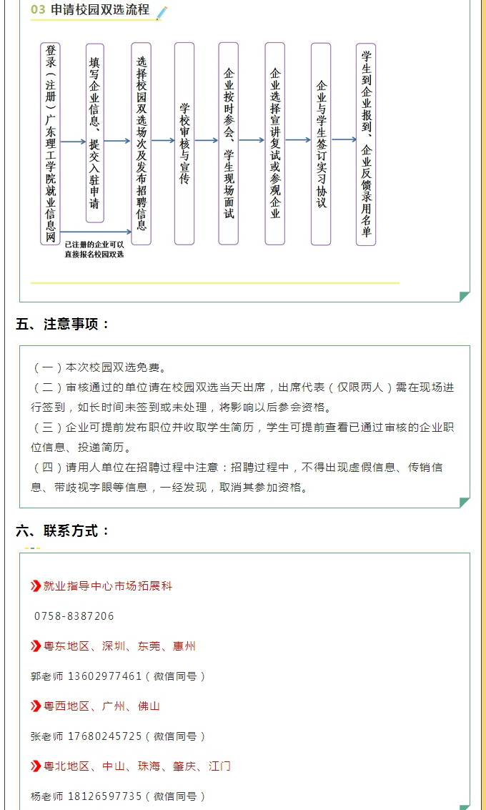

附件2

中山市赴外招聘活动参会人员名单（广东理工学院）

|  |  |  |  |  |  |  |  |  |  |  |
| --- | --- | --- | --- | --- | --- | --- | --- | --- | --- | --- |
| 序号 | 镇街 | 单位名称 | 姓名 | 性别 | 职务 | 手机号码 | 身份证号码 | 跟车/自驾 | 已报名  参会时间 | 备注 |
| 1 |  |  |  |  |  |  |  |  | 6月3日 |  |
| 2 |  |  |  |  |  |  |  |  | 6月10日 |  |
| 3 |  |  |  |  |  |  |  |  |  |  |
| 4 |  |  |  |  |  |  |  |  |  |  |
| 5 |  |  |  |  |  |  |  |  |  |  |
| 6 |  |  |  |  |  |  |  |  |  |  |
| 7 |  |  |  |  |  |  |  |  |  |  |
| 8 |  |  |  |  |  |  |  |  |  |  |